**Change Password**

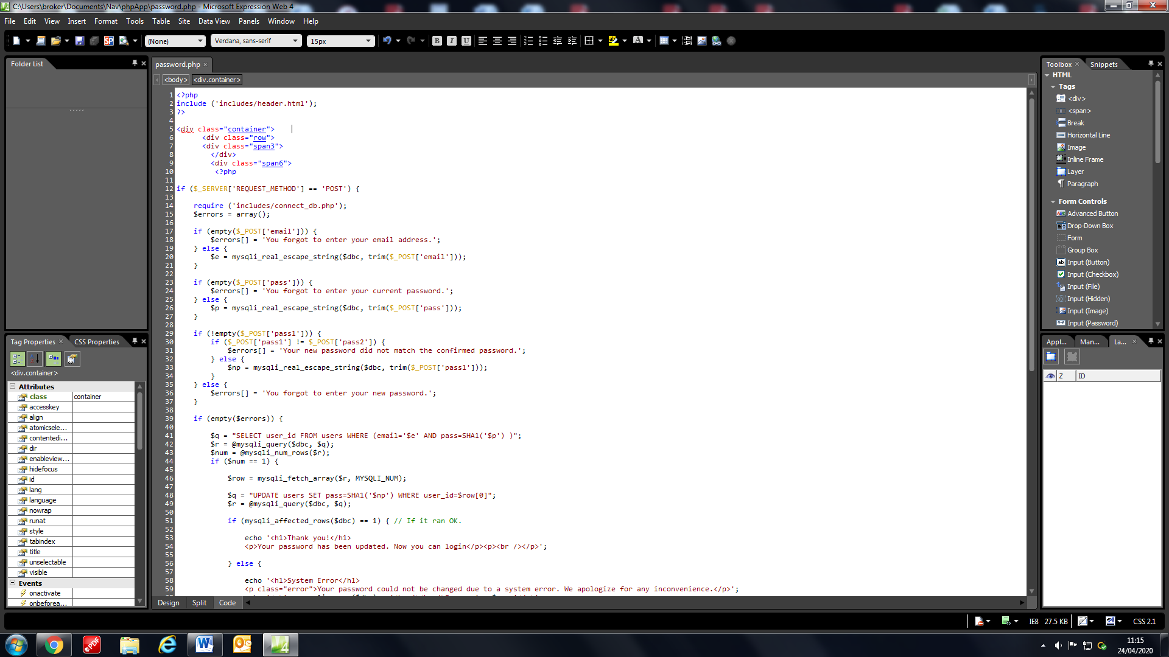



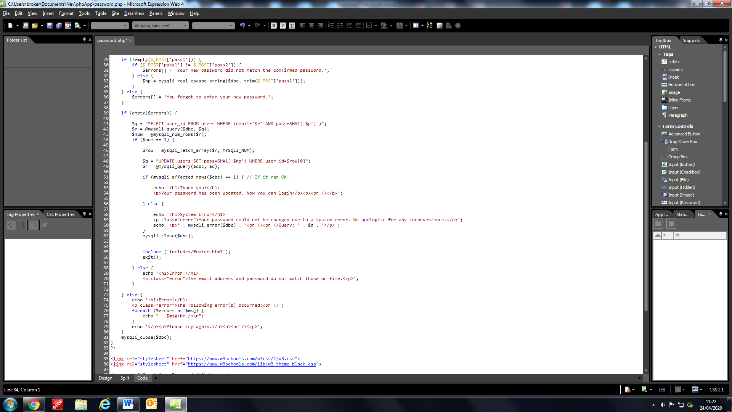

The change password page starts with some divs that splits up the page for it to be edited. It uses CSS by giving the divs class names which it grabs from the links provided in the header.html which is linked to the files within the CSS folder.

Then, this large IF statement starts by creating an array called errors which adds string errors if the user left a field empty or their new and confirm passwords are not the same. After if the errors array is not empty, it will output all the errors within the array. If the array is empty then it will grab the username from the users table that is on the same row as the email and the hashed version of the password that was given. If the SQL query returns with only 1 row then it changes the user’s password to the new one. If there is anything but 1 row then it informs the user that the email and password do not match. If for some reason there is an error with the connection to the database or it just does not work then it will inform the user and tell them their password has not changed.

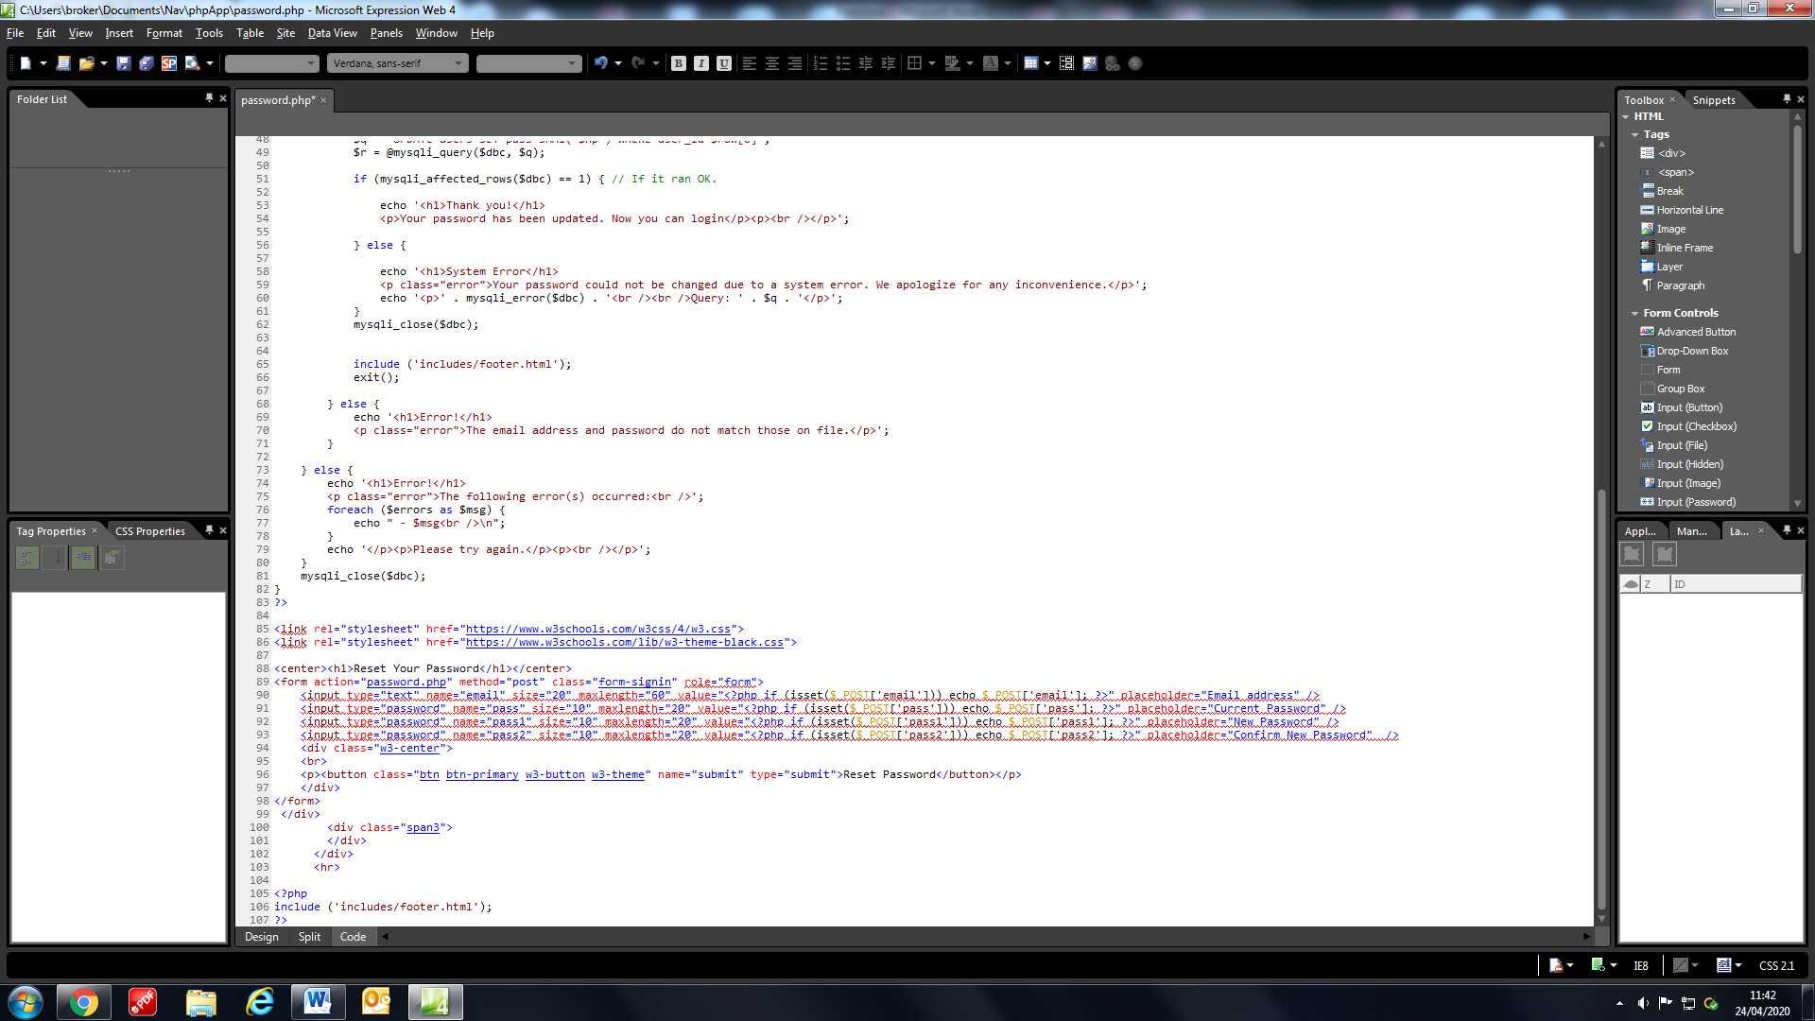

This HTML form collects the data from the fields using the PHP values in order to post it to the IF statement. When the button is clicked, the page is loaded again and the ‘POST’ data is collected and thus the IF statement for the page can start.

**Logout Page**

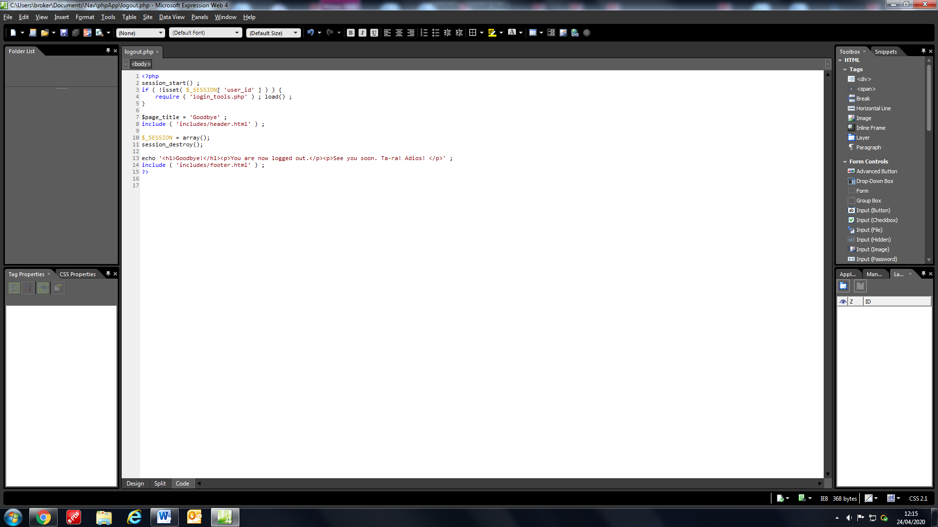

The logout page runs when a logged in user clicks logout in the header. First, it checks to see if the username slot has been filled i.e. it is not empty after, it calls the load function from the login_tools.php file, this allows the page to reset itself and load the login page. It also destroys all the session variables so that all the user details are removed. Finally, it replaces the admin/home header with the regular header and gives the user a message letting them know that they have logged out.

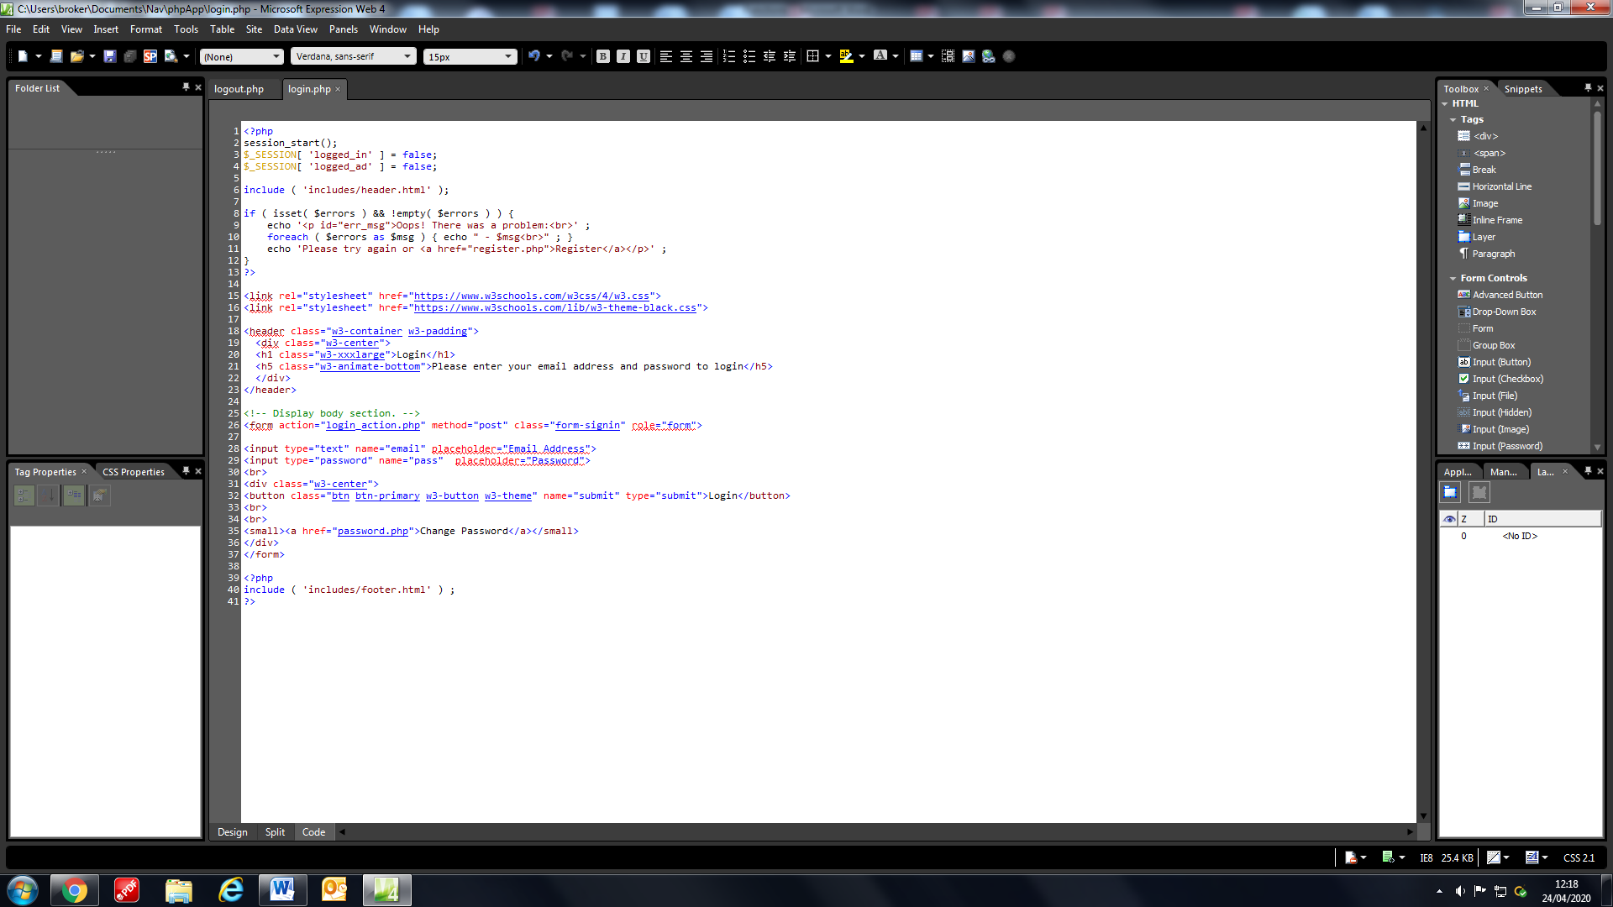

Since the login page is loaded this code at the start of it makes sure that the admin and user Boolean variables are reset, this way the normal header will load on each page until a user logs in again.